Step 2: Submit the Student Grade Grievance Form within 30 calendar days of the date grades are due to the Registrar's Office

Step 2 – The student submits a grade grievance
- A student will login to https://appsc2.svsu.edu/gradegrievance
- The student will click the “Submit New Form” button to be taken to the Step 2 form page.
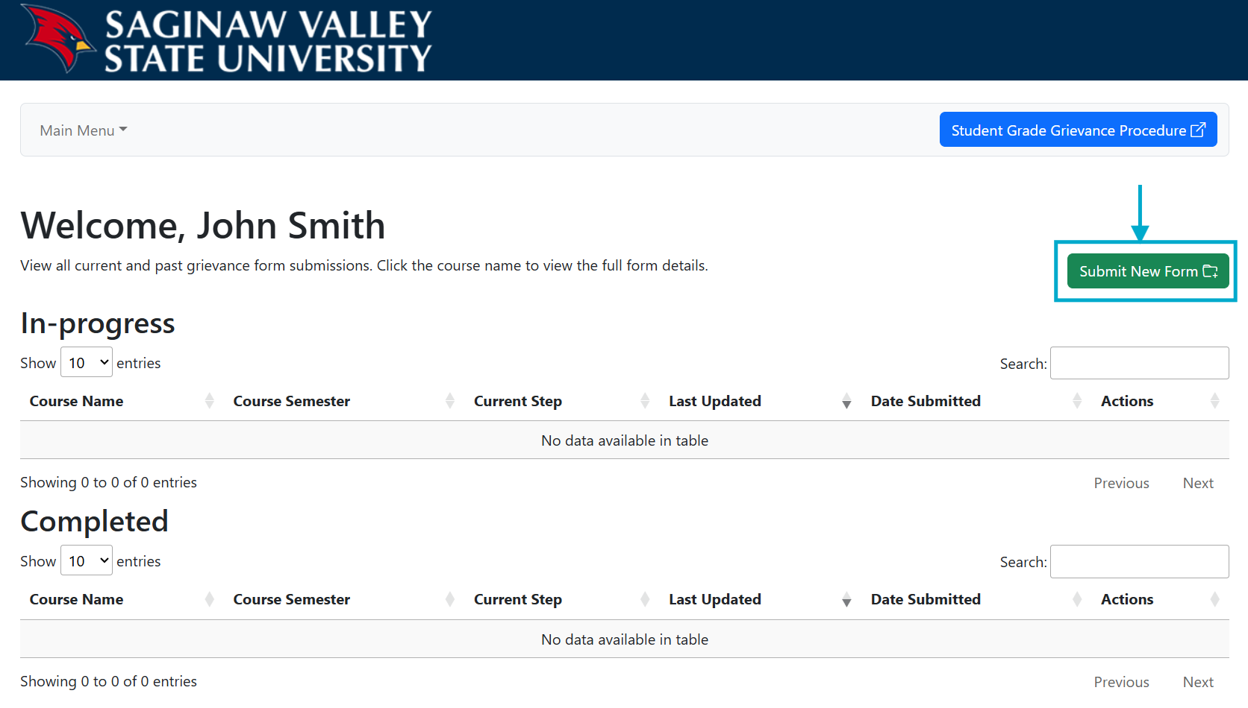

- In the Step 1 section, the student must confirm “yes” their final course grade has been filed and “yes” they communicated with the faculty member about their final course grade since the final grade has been filed.
- The student must upload evidence that the Step 1 discussion occurred such as email correspondence, a note from the professor, etc.
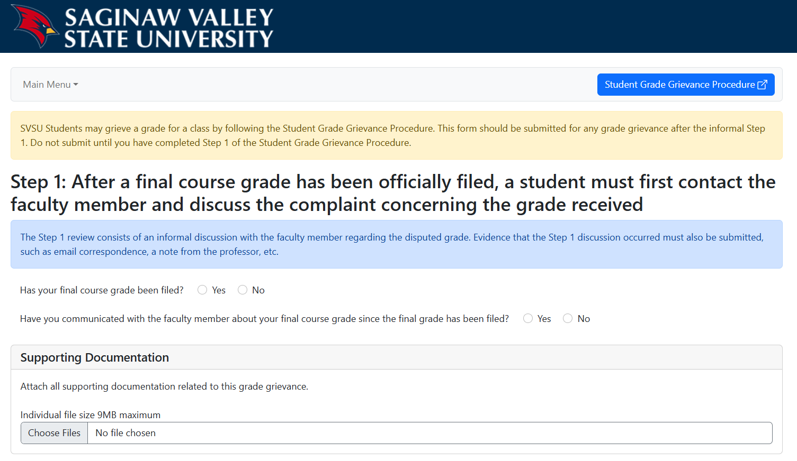

- In the Step 2 Course Information section, the student will select the Department, Number and Section of the course they are filing a grievance for.
  - Once all dropdowns are selected, the course instructor(s) will automatically populate into the form.
- In the Step 2 Grievance Information section, the student will enter a brief statement of grievance, a reason for lodging the grievance, and a specific proposed resolution for the grievance.
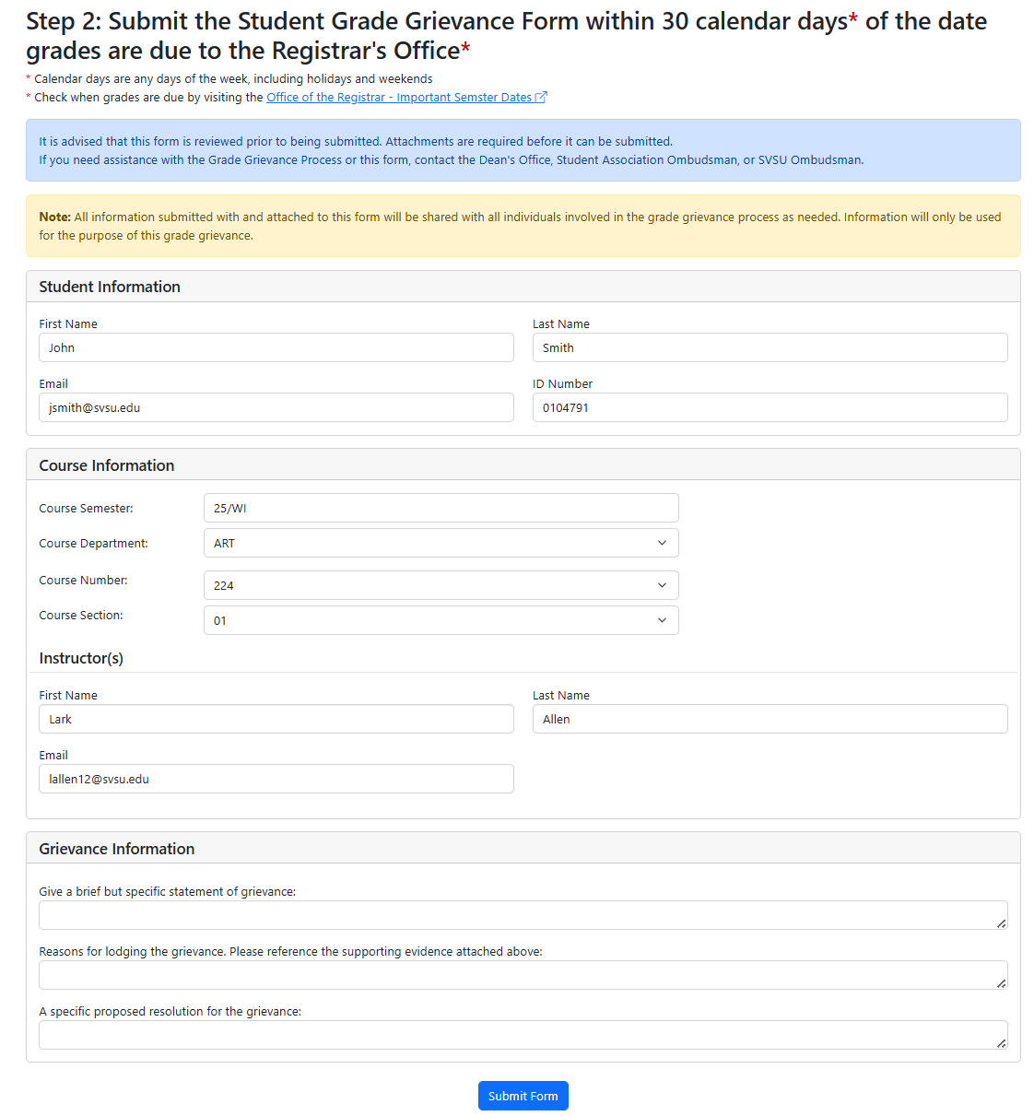
- The student will click “Submit Form” to file the grievance.
- A confirmation email is sent to the student, and a notification email is sent to all instructors, the department Chair, Associate Dean(s), Dean and Student Association.
  - All uploaded files are included in the outgoing email notifications as attachments.

Step 2 – The instructor has 4 business days to respond to the grievance or request a manual review of the grievance by the appropriate department Chair.
- The instructor will login to https://appsc2.svsu.edu/gradegrievance
- The instructor will click the pencil icon button in the corresponding row to review the form details and respond to the grievance.
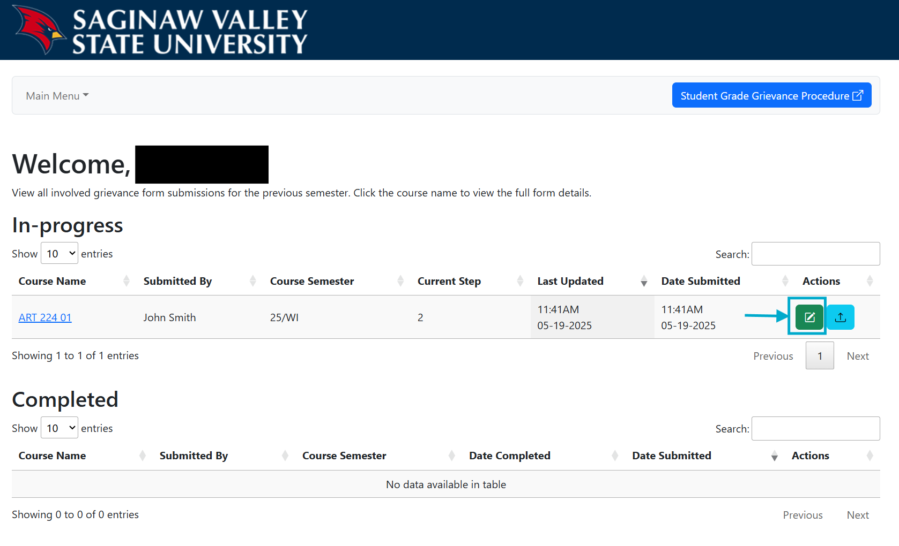

- In the “Next Steps” section, the instructor will be asked to confirm there was an informal review with the student after their final course grade was officially filed.
  - If the instructor selects “no”, a button is revealed to send an email request to the appropriate department Chair to manually review the validity of the grievance form.
    - After reviewing the grievance details and uploaded evidence files, the Chair should communicate with both the student and faculty to make a final determination that the student satisfied the Step 1 informal review requirements.
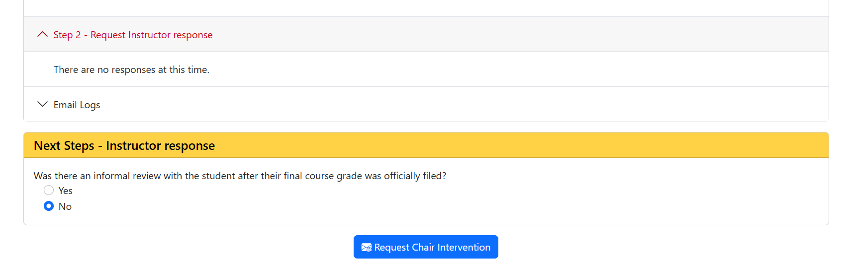

  - If “yes”, the instructor will enter their closing response to the grade grievance, indicating the proposed resolution is accepted and the form will be resolved and completed.
- In this case the instructor selects “no” and clicks the revealed “Add Response” button that will take them to a new form page.
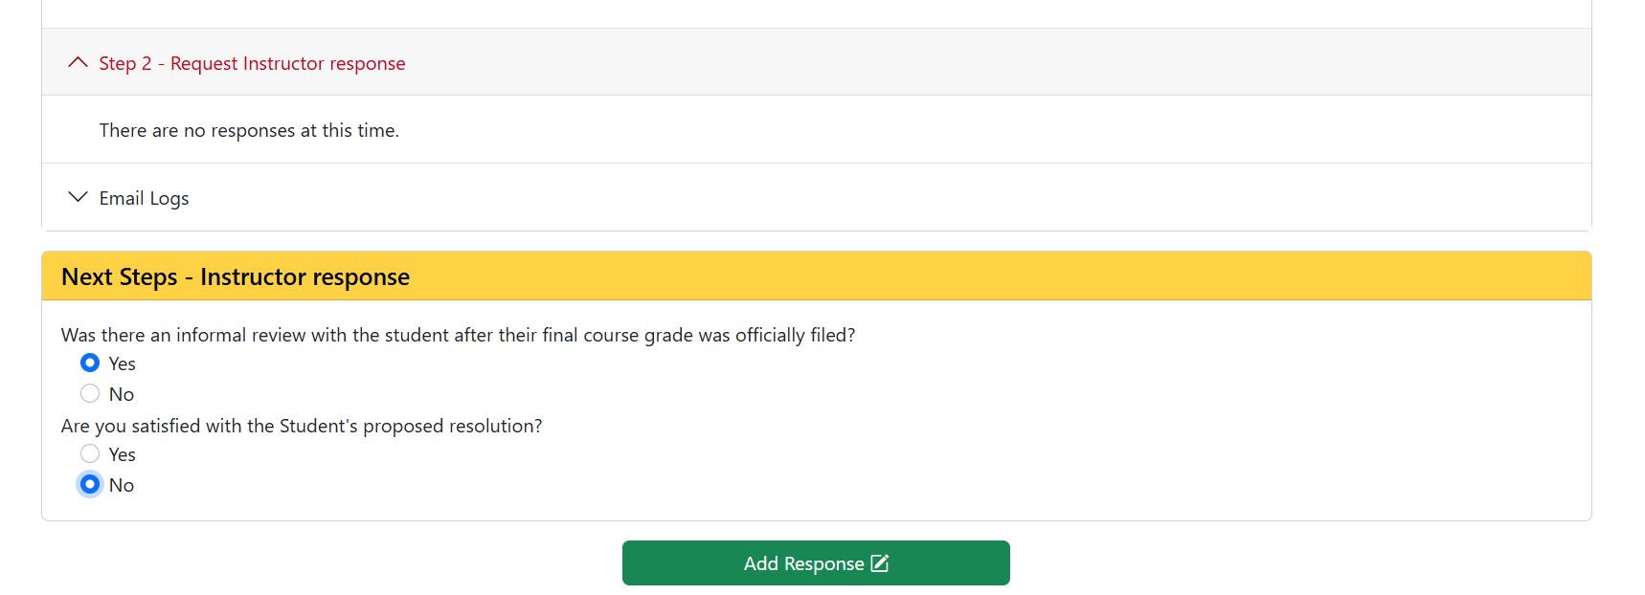

- In the “Instructor Response - Step 2” section of the form, the instructor will enter their written response to the grievance indicating whether the proposed resolution is rejected or offer an alternative resolution.
- Optionally, the instructor can upload any additional supporting documentation related to the grade grievance.
- The instructor clicks “Submit Step 2 Response” to submit their written response to the student.
  - A notification email is sent to the student, the instructor(s), the department Chair, Associate Dean(s), Dean and Student Association.
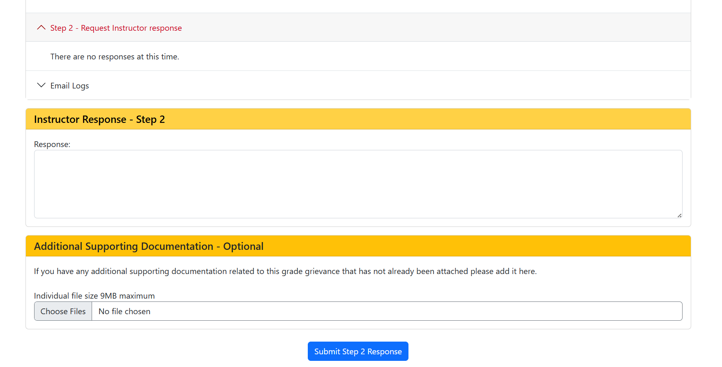

Step 2 – The student has 3 weekdays to review instructor’s response and make a request to the appropriate Chairperson
- The student will login to https://appsc2.svsu.edu/gradegrievance
- The student will click the pencil icon button in the corresponding row and review the instructor’s response.
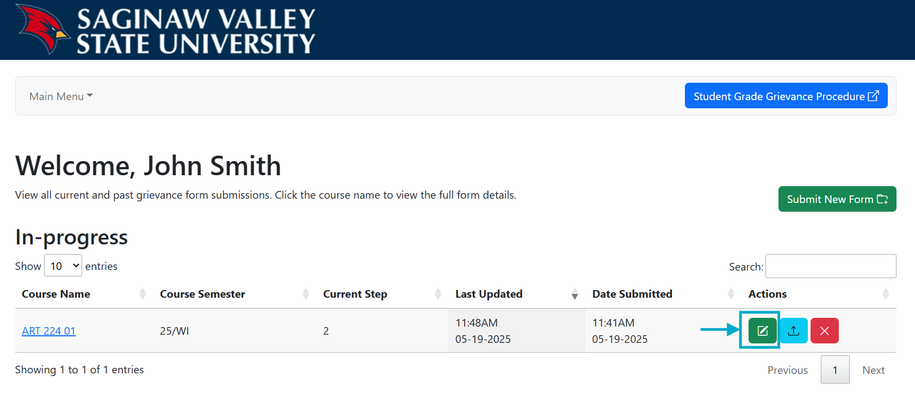

- In the “Next Steps” section, the student will be asked if they are satisfied with the instructor’s response.
  - If “yes”, the student will enter their closing statement to the grade grievance, indicating the proposed resolution is accepted and the form will be resolved and completed.
- In this case the student selects “no” and clicks the revealed “Start Step 3” button to take them to the Step 3 form page.
  - In cases where the instructor is also the Chairperson, instead they are taken to the Step 4 form.
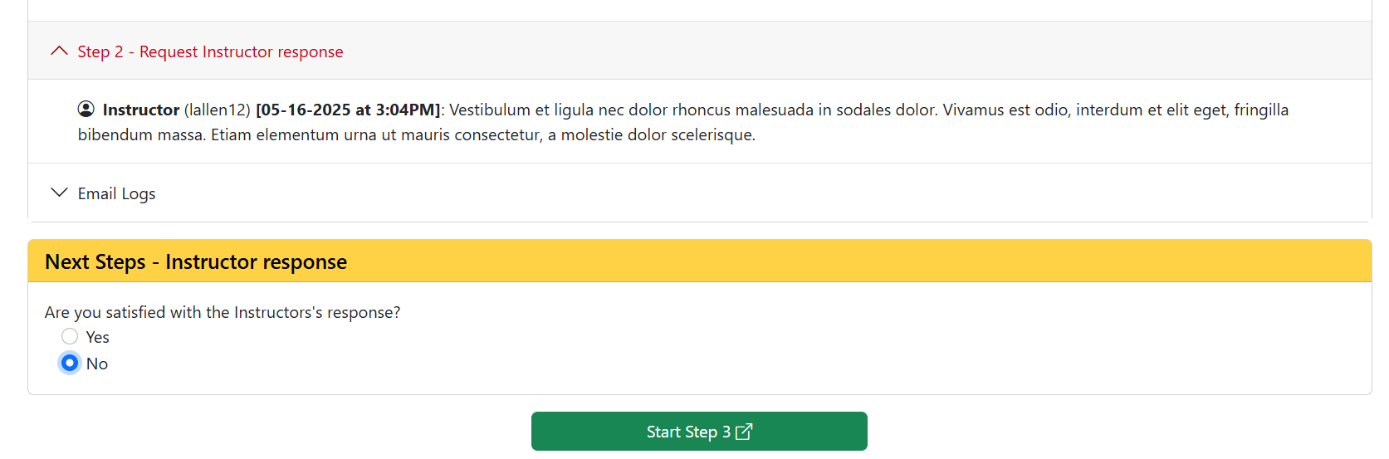

Step 3: Request recommendation from department Chair
- On the Step 3 form, the student will enter their reason for continuing the grievance.
  - The appropriate Chairperson is automatically populated into the form.
- Optionally, the student can upload any additional supporting documentation related to the grade grievance.
- The student will click “Submit Form” to file Step 3 of the grievance.
  - A notification email is sent to the student, the instructor(s), the department Chair, Deans and Student Association.
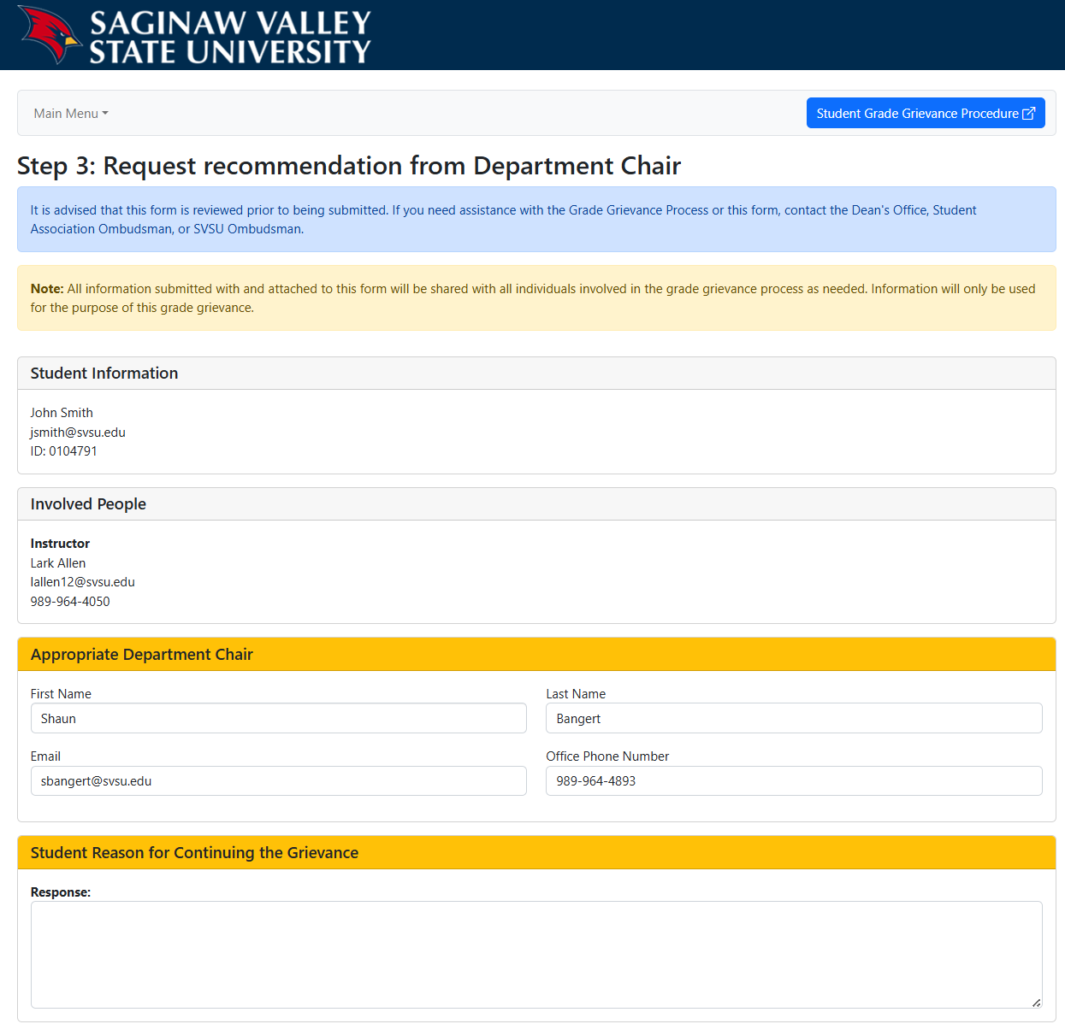

Step 3 - The Chairperson has 6 business days to respond to the grievance
- The Chair will login to https://appsc2.svsu.edu/gradegrievance
- The Chair will click the pencil icon button in the corresponding row and review the form details. Click the Step headers to expand the section to view the previous comments.

- Note: The application homepage will only display grievances that have reached the step the logged in user is involved in.
  - The chairperson can view and manage all grievances submitted to their department before they reach Step 3 by clicking the “Main Menu” navigation dropdown and clicking “View All Recent Semester Form Submissions”.
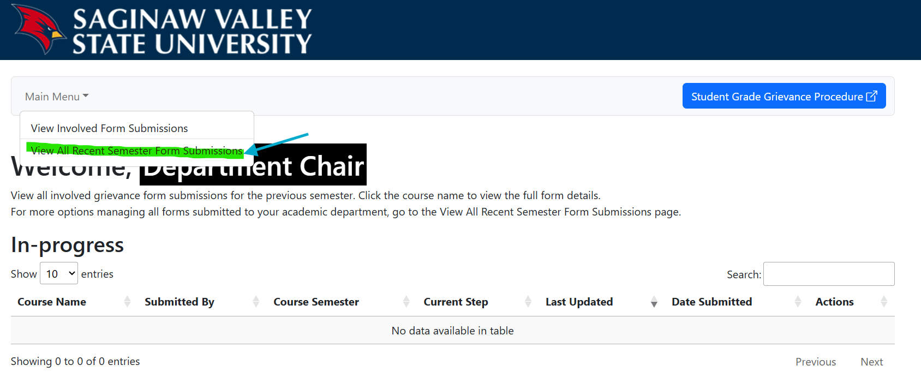

- The Chairperson will enter their recommendation in the “Department Chair Response – Step 3” section, agreeing with the student or instructor, or proposing an alternative resolution.
- Optionally, the Chairperson can upload additional supporting documentation related to the grade grievance.
- The Chair will click “Submit the Step 3 Response” to submit their written recommendation.
  - A notification email is sent to the student, instructor(s), Chair, Deans and Student Association.
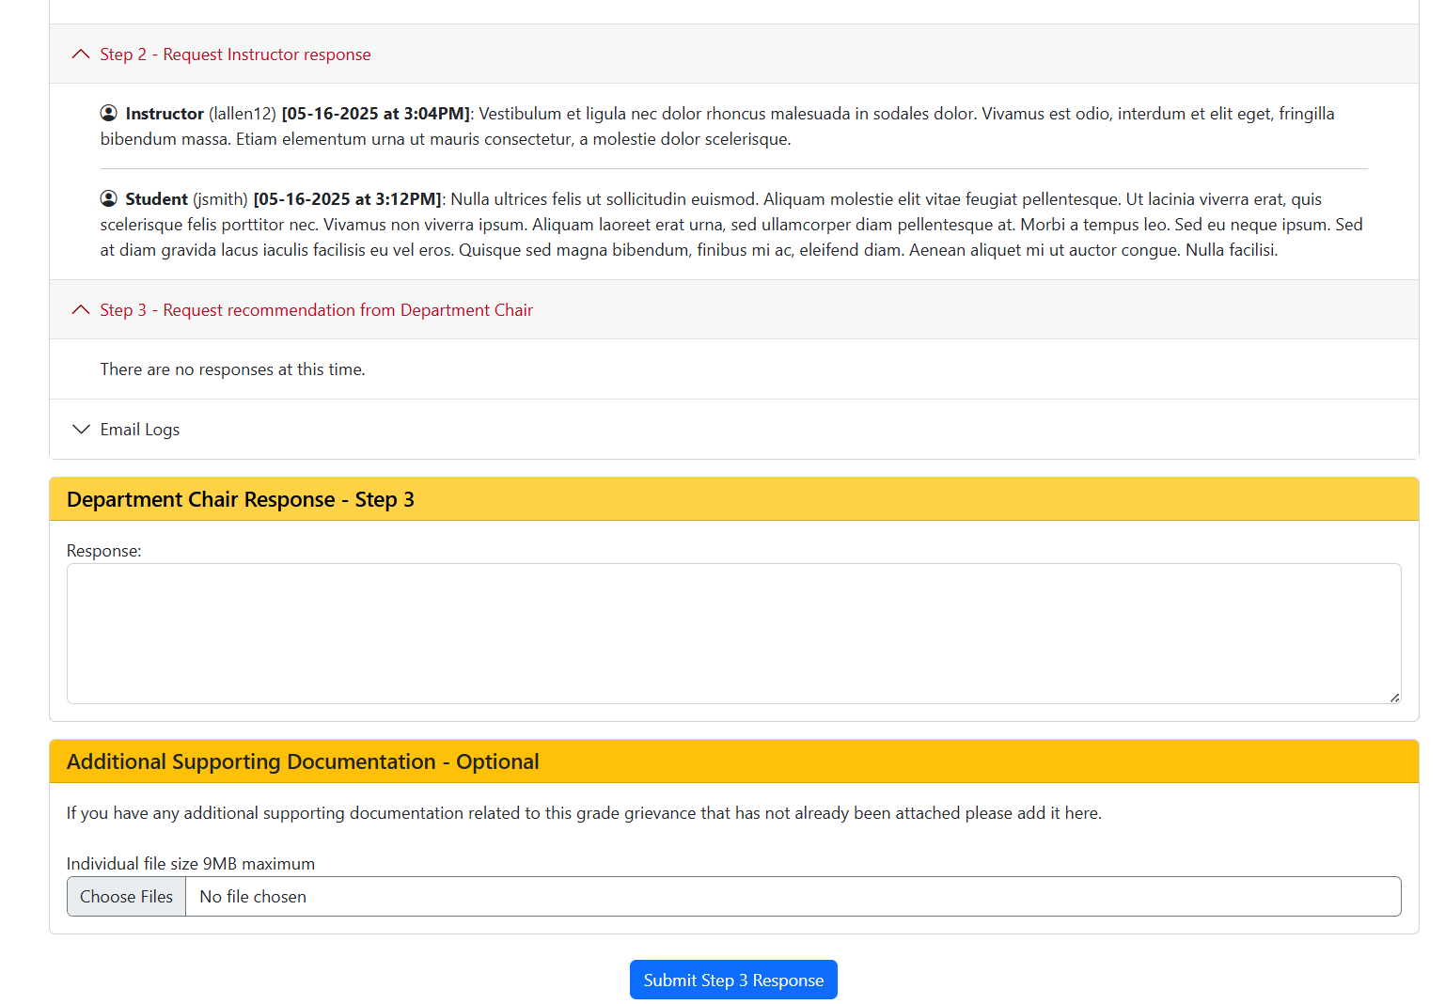

Step 3 – the student and instructor have 3 business days to respond to the Chairperson’s recommendation
- Both the student and instructor must agree with the Chair’s recommendation, or the grievance can continue to Step 4.
- In this case the student will login to https://appsc2.svsu.edu/gradegrievance
- The student will click the pencil icon in the corresponding row to review the form details.
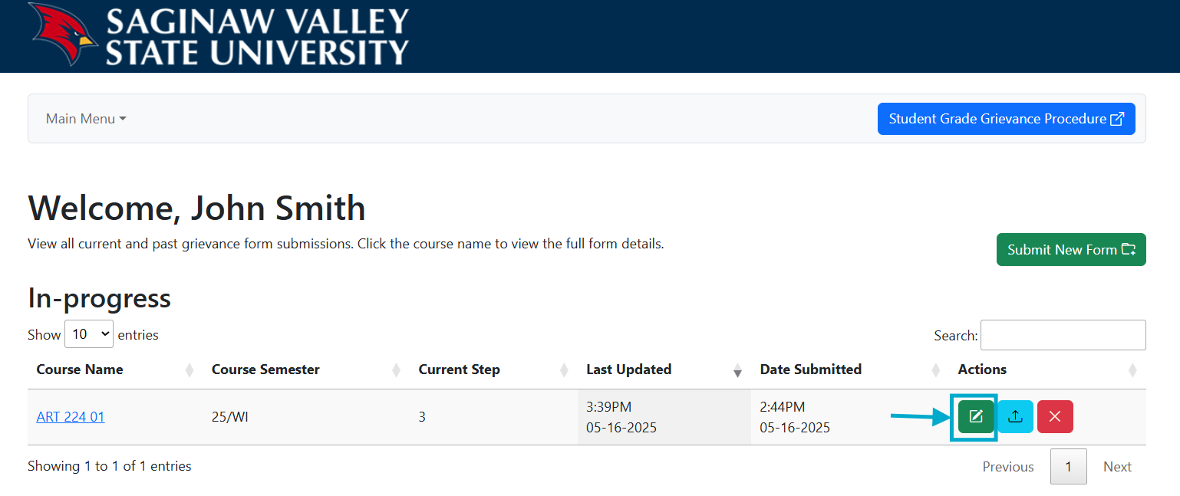

- In the “Next Steps” section, the student will be asked if they are satisfied with the Chairperson’s recommendation.
  - If “yes” the student will enter their closing response to the grade grievance, indicating the proposed resolution is accepted. The form will be closed at this step if the instructor also logs in and accepts the recommendation.
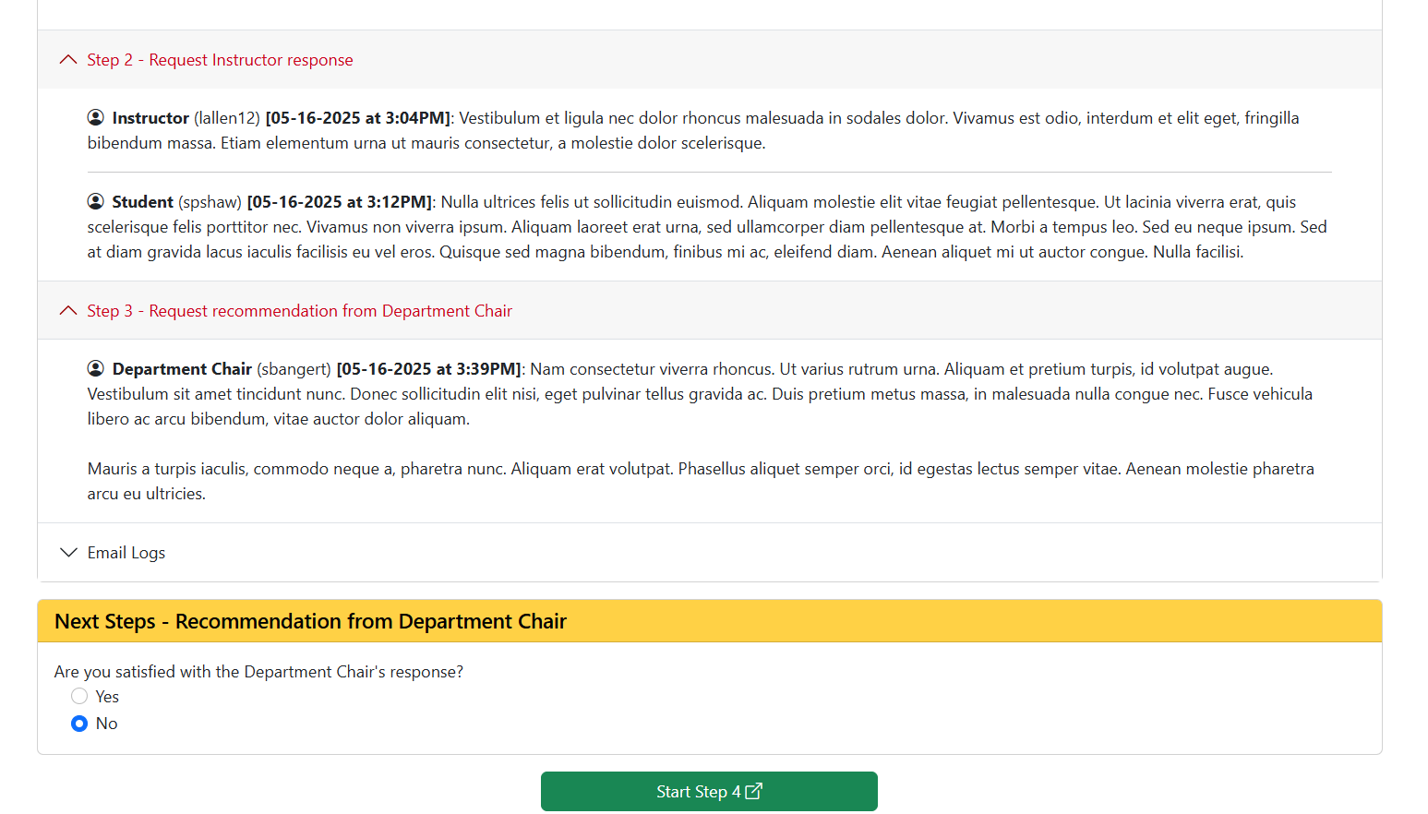
- In this case, the student selects “no” and clicks the revealed “Start Step 4” button that will take them to the Step 4 form.

Step 4: Request Dean to call a hearing
- On the Step 4 form, the student will enter their reason for continuing the grievance.
  - The appropriate Deans are automatically populated into the form.
- Optionally, the student can upload additional supporting documentation related to the grade grievance.
- The student will click “Submit Form” to file Step 4 of the grievance.
  - A notification email is sent to the student, the instructor(s), Chair, Deans and Student Association.
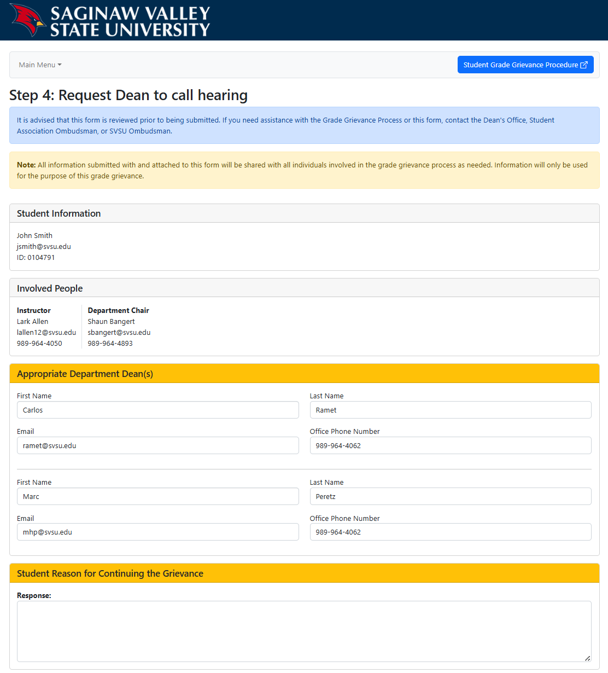

Step 4 – the Dean schedules the committee hearing
- After the appropriate Dean has worked with the student, faculty members, and student association to schedule a date and time for the committee meeting, they will login to https://appsc2.svsu.edu/gradegrievance
- Note: The application homepage will only display grievances that have reached the step the logged in user is involved in.
  - The Dean can view and manage all grievances submitted to their department before they reach Step 4 by clicking the “Main Menu” navigation dropdown and clicking “View All Recent Semester Form Submissions”.
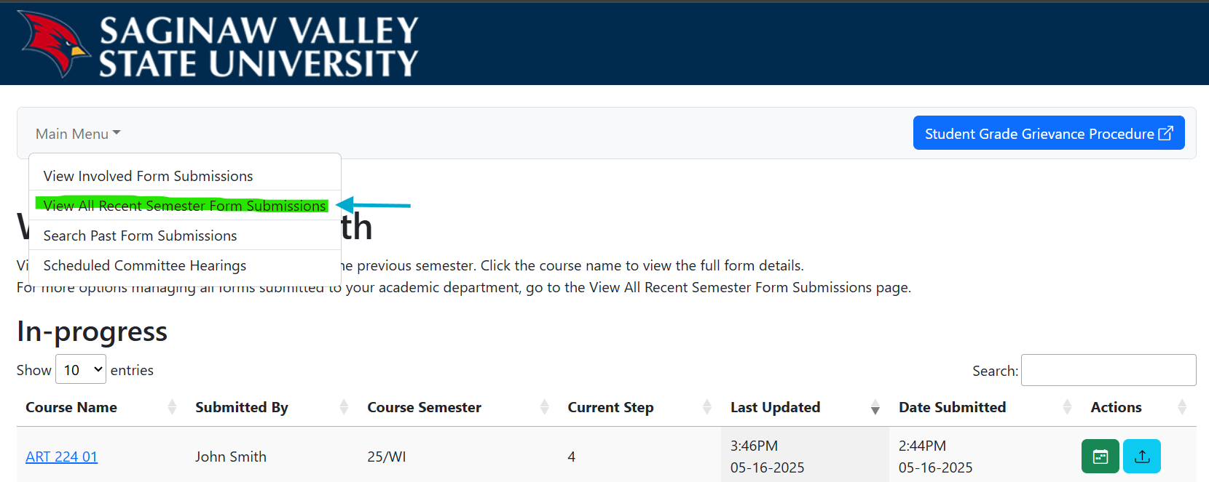

- The Dean will click the green calendar icon to be taken to the form to enter the meeting details.
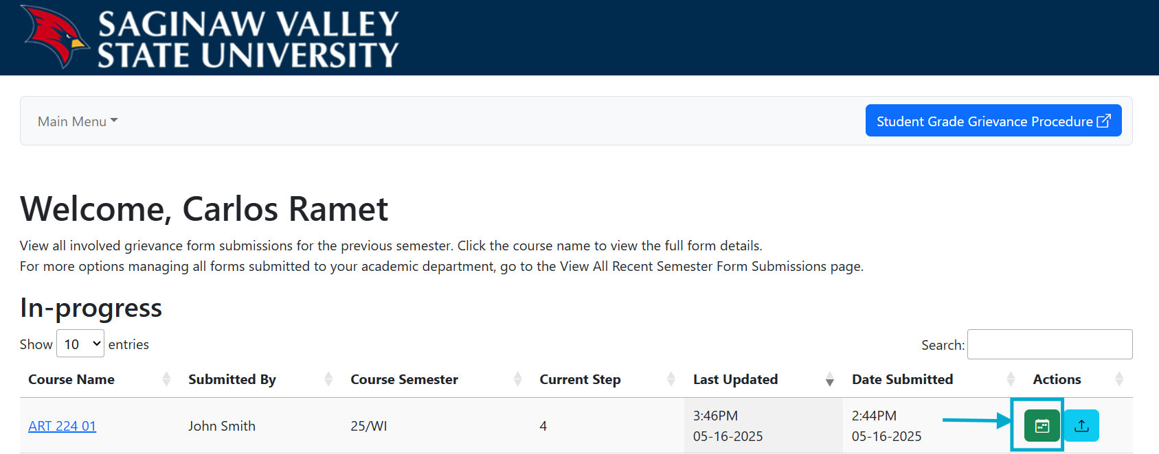
Department Dean

- The Dean will select the correct grievance form and enter the hearing date and time, and select if the meeting will be online, in-person or a hybrid of the two.
  - The meeting type is retained for record/data analysis purposes by the Provost, the grade grievance application does not include the meeting type in any outgoing notifications.
- The Dean will enter the enter the contact information for the student association representative, 3 faculty members and 3 students that will be participating in the committee hearing.
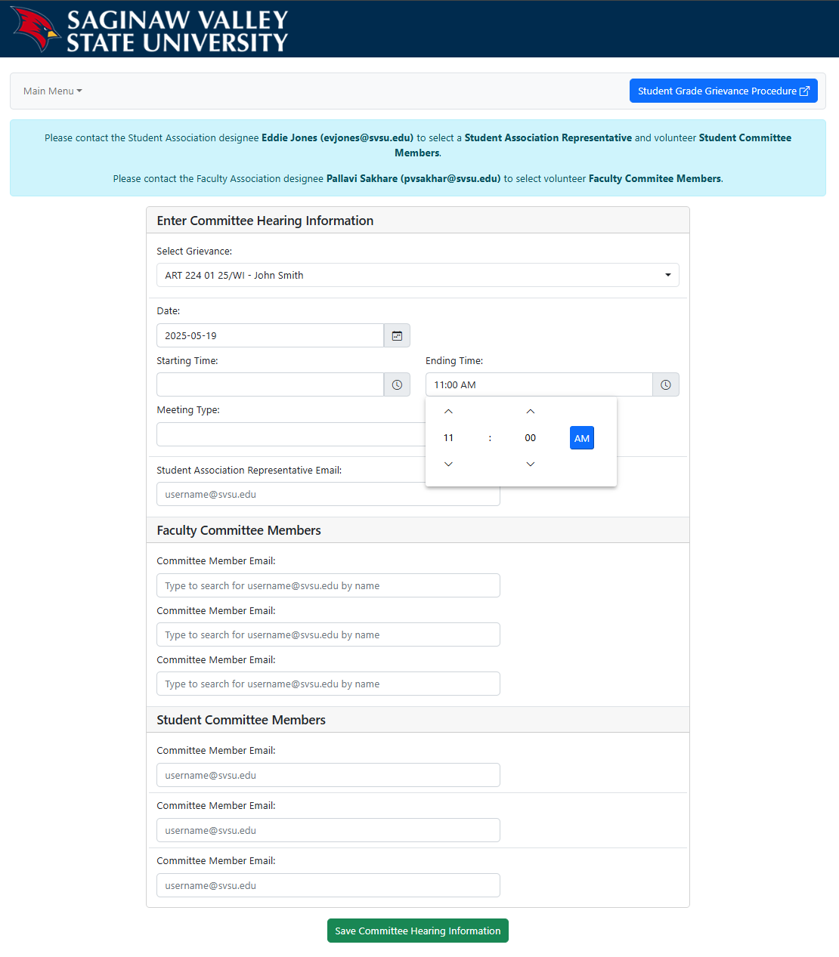
- The Dean will click the “Save Committee Hearing Information” to save the committee meeting details.
  - A notification email with the hearing date and time is sent to the student.
- A second confirmation email with the hearing date and time is sent to the involved instructor(s), Chair, Dean(s), and Student Association.
- A third confirmation email with the hearing date and time is sent to the listed committee members and Student Association representative.
  - This email includes attachments of all uploaded evidence files and a pdf summary of the initial grievance form with the student and instructor information redacted for review before the meeting.
- Note: The presiding Dean can reschedule the committee date and time or edit the volunteer committee members any time before the scheduled meeting start time by clicking the yellow calendar icon in the corresponding row from the “View Involved Form Submissions” page or the “Scheduled Committee Hearings” page.
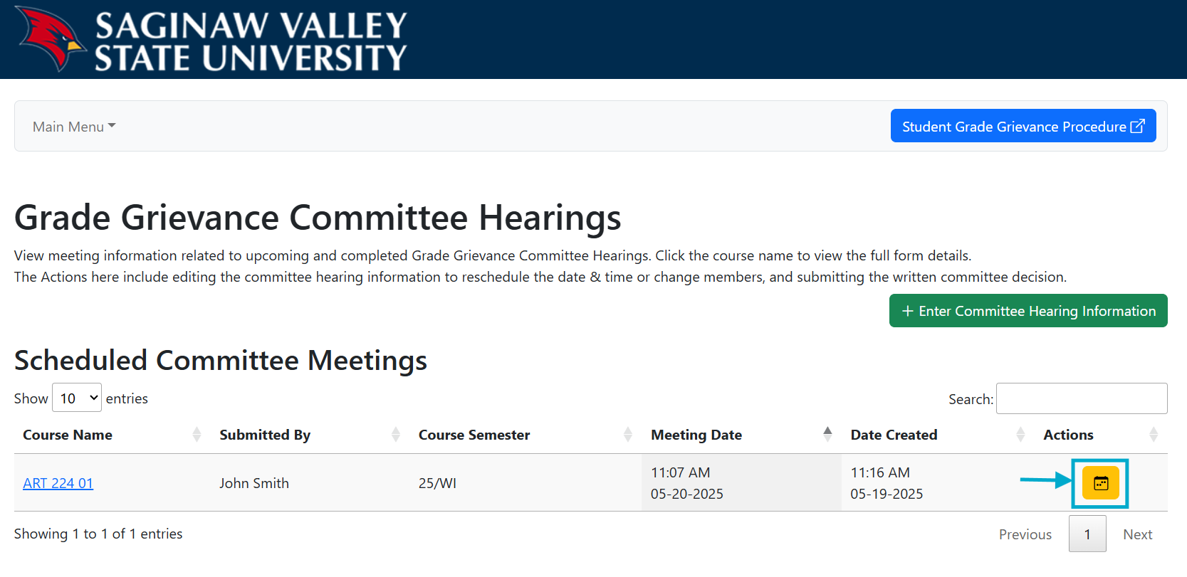

- Once the committee hearing has concluded, the appropriate Dean will login to https://appsc2.svsu.edu/gradegrievance
- The Dean will click the pencil icon in the corresponding row to be taken to a form to record the committee decision.
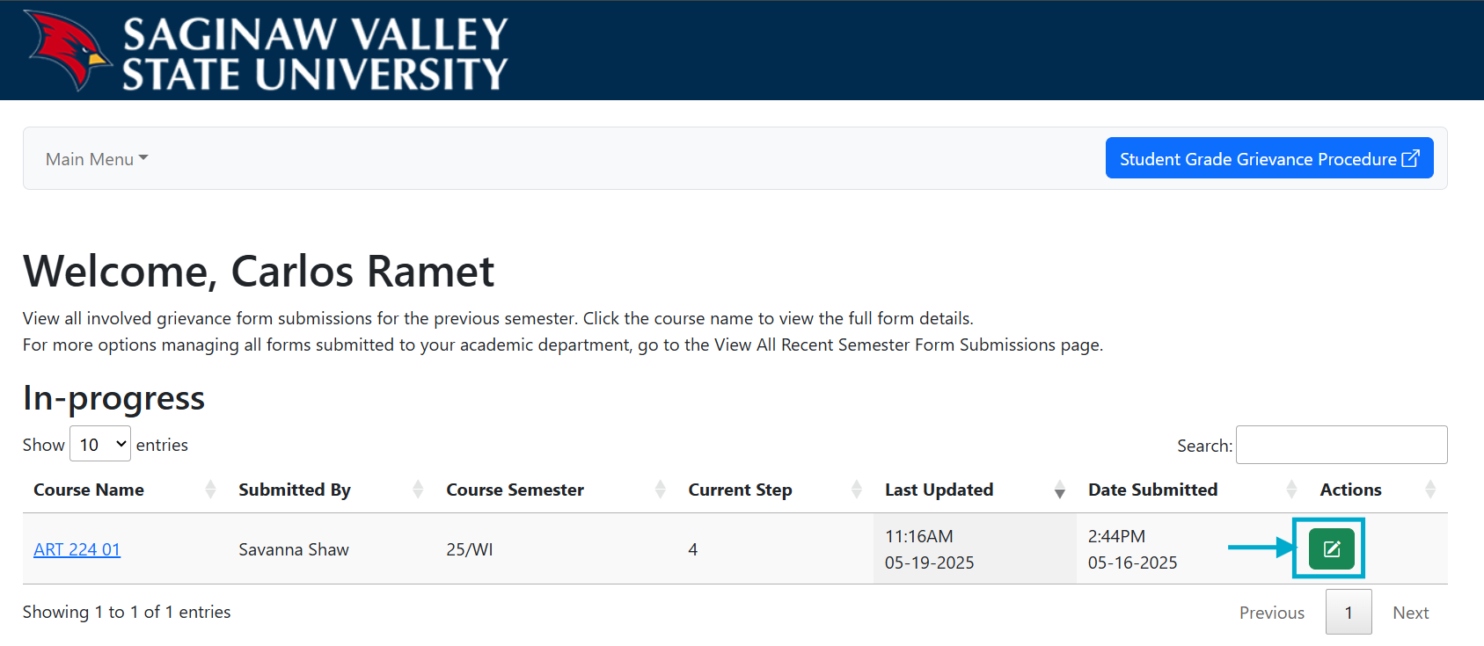
Department Dean

- The Dean will enter the final decision of the committee in the “Dean Committee Hearing Response – Step 4” section.
- The Dean is required to upload the grade grievance hearing memo.
- The Dean will click “Submit Step 4 Response” to save the decision to the grievance.
  - A notification email is sent to the student, instructor(s), Chair, Deans, Student Association, and the Provost and their Representative.
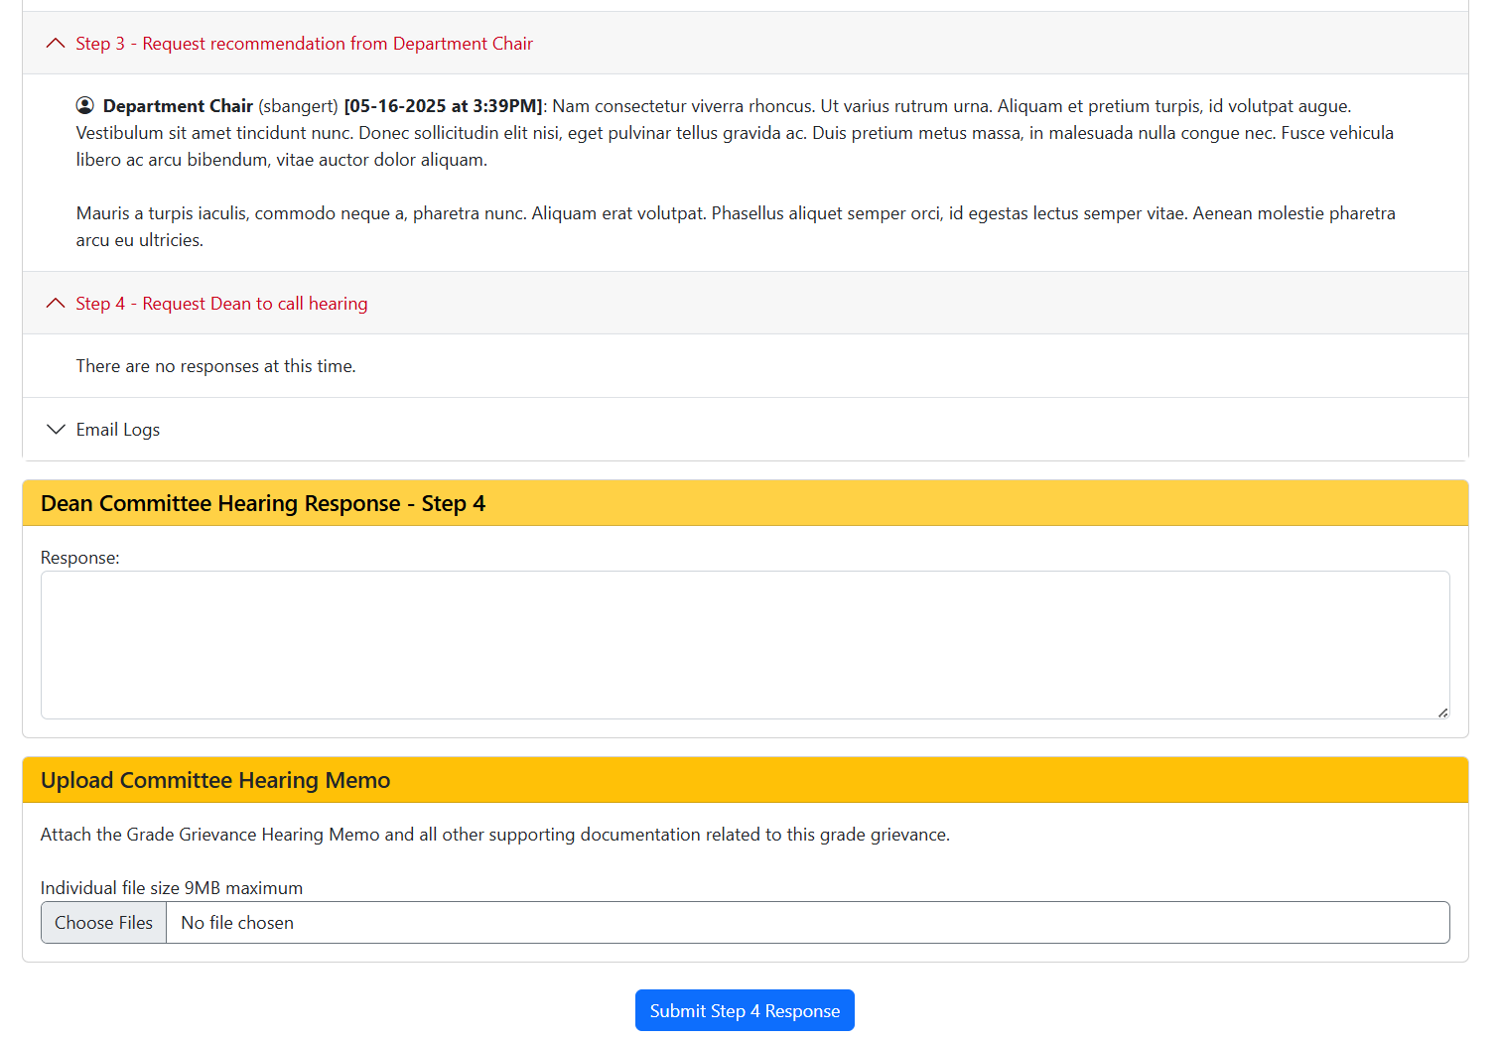

Step 4 – the student and instructor have 3 business days to review the committee decision
- Both the student and instructor must agree with the grade grievance committee decision, or the grievance can continue to Step 5.
- In this case, the student will login to https://appsc2.svsu.edu/gradegrievance
- The student will click the pencil icon in the corresponding row to review the form details.

- In the “Next Steps” section, the student will be asked if they are satisfied with the Grade Grievance Committee Hearing decision.
  - If “no”, the student would click the “Start Step 5” button to be taken to the Step 5 form.
- In this case the student selects “yes” and enters their closing response to the grade grievance, indicating the committee decision is accepted.
- The student clicks the “I agree” button to submit their closing statement.
  - An email notification is sent to the student, instructor(s), Chair, Deans and Student Association.
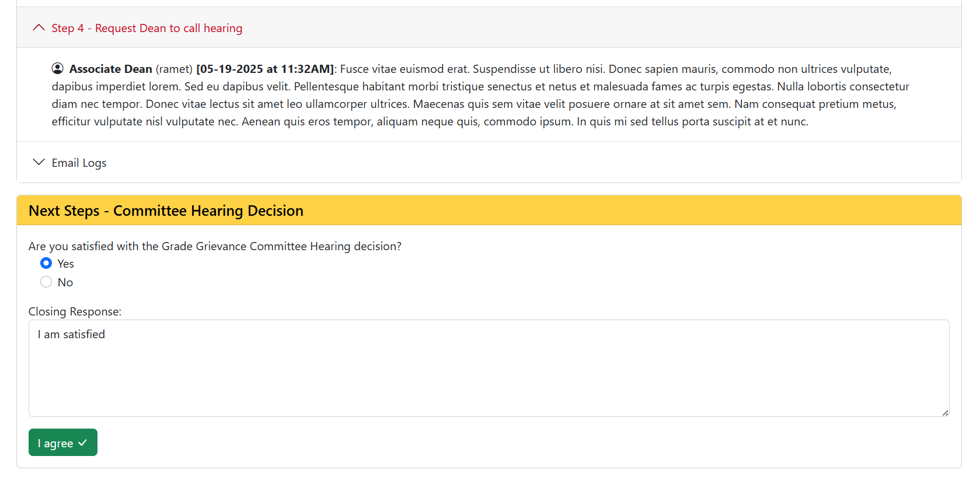

- The instructor will login to https://appsc2.svsu.edu/gradegrievance
- The instructor will click the pencil icon on the corresponding row to review the form.

- In the “Next Steps” section, the instructor will be asked if they are satisfied with the Grade Grievance Committee Hearing decision.
  - If “no”, the instructor would click the “Start Step 5” button to be taken to the Step 5 form.
- In this case the instructor selects “yes”, and enters their closing response to the grade grievance, indicating the committee decision is accepted.
- The instructor clicks the “I agree” button to submit their closing statement.
- In this case the form will be completed at Step 4 since the student has also accepted the committee’s decision.
  - An email notification is sent to the student, instructor(s), Chair, Deans and Student Association.
